NORTH-WEST UNIVERSITY
MAFIKENG CAMPUS

SECHABA FURNITURE MANUFACTURING(LITCHENBURG)

CMPG 324

DUE SATE :28 AUGUST 2026

CLIENT’S REQUIREMENTS
Sechaba Furniture manufacturing ‘s network needs to support both business operation and production system. The main requirements for the network are:
- High- speed connectivity: the network should allow fast communication between computers, servers, production machines and databases.
- Reliability and availability: for the network to work efficiently, production should continue even if one network device or connection fails. Having more switches, links, and backup connections can help.
- Security: the network should have strong security measures to prevent outsiders from gaining access to the company’s network. The security measures should protect company data, production systems, intellectual property and machinery from unauthorized access and cyberattacks
- Scalability: the network should allow new employees’ machines, sensors, production lines, and branches to be added easily.
- Wireless Connectivity: the network should provide Wi-Fi for employees, warehouse devices, mobile equipment and scanners that are used for payments.
- Segmentation: to easily manage the network, the network needs to have segmentation which is separation of the departments within the network to improve security and performance.
- Remote access: The employees and technicians may need secure access to the system when working remotely or supporting equipment
- Data storage and backup: network data such as employee data, financial records and production orders and payments should be backed up regularly to prevent loss of data.
- Error detection and correction: the network should allow administrators to detect network problems, unusual traffic, monitor devices and control network access.

Network Devices
Devices | Role | Packet tracer model
R1 | Edge router: | 2911
SW1 | Distribution switch: EtherChannel member, trunk to R1 | 2960
SW2 | Access Switch: EtherChannel member, devices access port | 2960
PC-Admin | End device, VLAN 10 (Administration) | PC
PC-Production | End device, VLAN 20(Production floor) | PC
PC-Warehouse | End devices, VLAN 30(Warehouse) | Server
Server-Future | Placeholder in VLAN 40, port shut down until server arrives | PC (on ISP side)
PC-offsiteAdmin | Represents the remote administrator, sits beyond R1’s WAN link | ISP side

Assigned Networking Challenge
The assigned network is EtherChannel (Link aggregation).
EtherChannel (link aggregation) is the process of combining multiple physical network cables or ports into a single logical connection to increase bandwidth and provide redundancy. In this project we will Combine multiple physical links using LACP on both switches with channel-group 1 mode active. LACP is an open standard, making it preferable if the company later uses switches from different vendors. For Sechaba manufacturing I chose LAPC Over PAgP because it provides redundancy and bandwidth aggregation while being an industry standard protocol rather than a Cisco-proprietary solution.
SW1 and SW2 can operate as a single logical port-Channel.
This provides Increased bandwidth as the traffic within the network can use multiple physical links. If one cable/link fails, the remaining link can continue carrying traffic. This will make management easier and simpler as the bundled links are treated as one logical connection.

TOPOLOGY
1.PHYSICAL TOPOLOGY.
Sechaba furniture manufacturing network will use star topology. This is because each department’s device connects to a central access switch, making the network easier to install, manage and troubleshoot. The topology also supports VLAN’S configuration, link aggregation (LACP) connection between SW1 and SW2 and secure the network through SSH.
Troubleshooting: If the PC- administration fails, you can check on the cable or the specific SW2 port without taking down the rest of the network.
Easy to expand: If the company decides to add more computers, printers, or servers, they can simply be connected by an additional switch port.

Logical Topology.
The logical topology is a VLAN -based hierarchical switched topology. SW2 acts as the access switch connecting the departmental devices, while SW1 acts as the distribution switch and R1 performs inter-VLAN routing. VLAN’s 10,20,30,40 and 99 logically separate administration, Production, Warehouse and Management traffic. Communication between different VLANs is routed through R1. Therefore, although the physical topology is a star , the logical topology is based on VLAN segmentation, trunking and inter-VLAN routing.
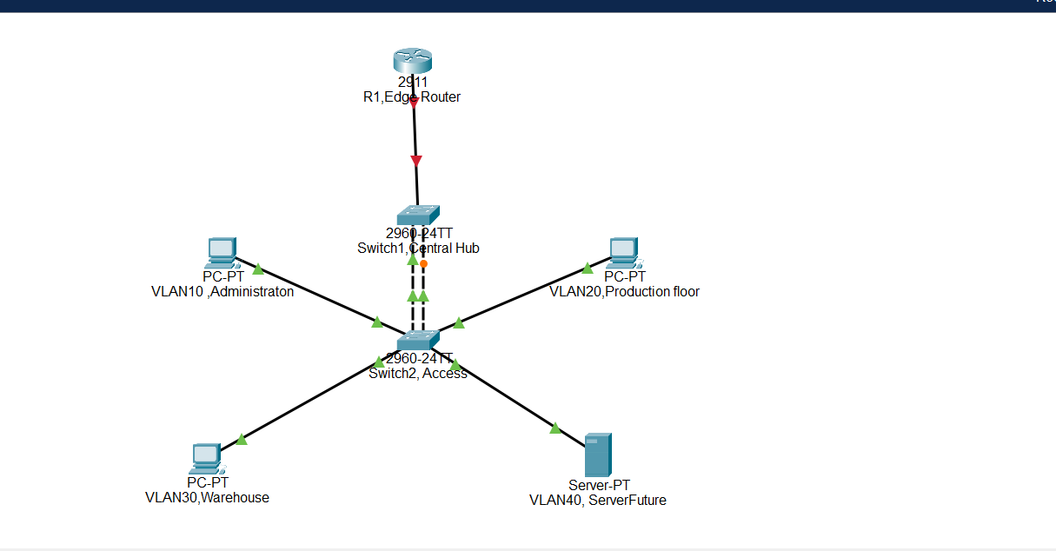

IP ADDRESSING PLAN

VLAN | NAME | SUBNET | USABLE RANGE | GATEWAY
10 | Administration | 172.30.18.0/26 | .1 - .62 | 172.30.18.1
20 | Production Floor | 172.30.18.64/26 | .65 - .126 | 172.30.18.65
30 | Warehouse | 172.30.18.128/26 | .129 - .190 | 172.30.18.129
40 | Servers(future) | 172.30.18.192/27 | .193 - .222 | 172.30.18.193
99 | Management | 172.30.18.224/27 | .225 - . 254 | 172.30.18.225

